**OUTREACH SCHOOLS EXAMINATION BOARD**

**MID TERM III EXAMINATION 2023**

**TOP CLASS: (5 – 6 YEARS)**

**LEARNING AREA 2: LANGUAGE DEVELOPMENT I**

**My name is: ……………………………………………………………….**

**My School is: …………………………………….………………………..**

**I am in: ………………………………..…………………………….…………………..**

1. **Name the pictures.**

|  |  |  |
| --- | --- | --- |
| D:\Local Disk F\New folder\SECRETARY\NEW PICS\NEW PHOTOS\pencil nursery.jpg | D:\Local Disk F\New folder\KIBUUKA 2023\pictures\kibuuka pic\NEW PICS\MY PHOTOS\PICTURES\Apple 2 - Copy.jpg | D:\Local Disk F\New folder\SECRETARY\NEW PICS\MY PHOTOS\PICTURES\LISA EVE\cup - Copy.jpg |
|  |  |  |

1. **Match words to pictures.**

stool

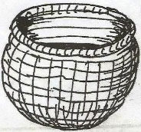

chair

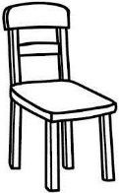

basket



moon

1. **Write sentences using This is a…………**

This is a book.

 _______________________________

________________________________

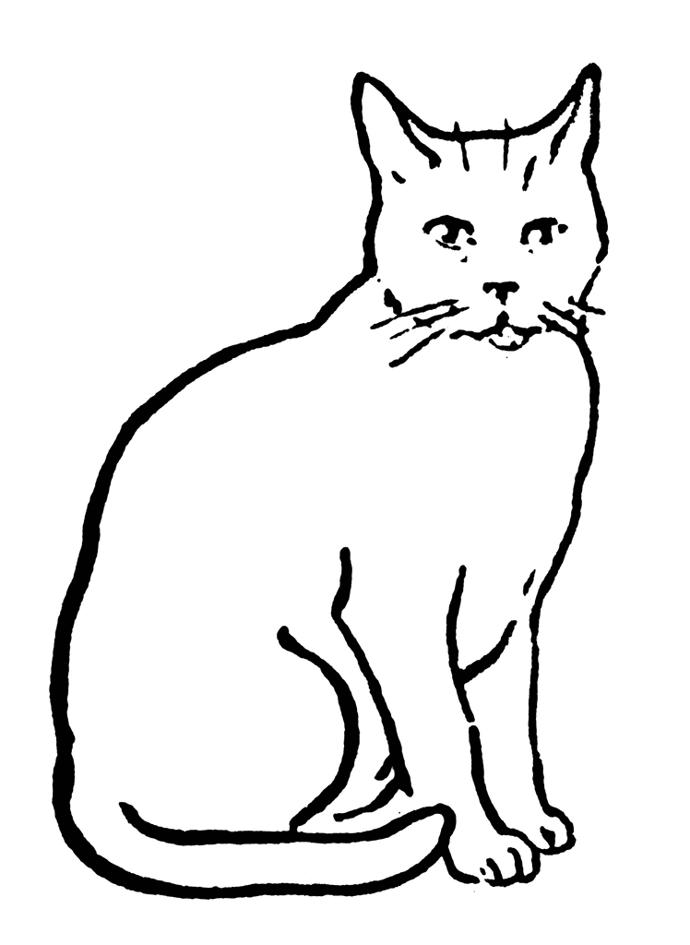

_________________________________

1. **Read and draw.**

That is a girl.

I can see a hat.

The bottle is on the table.

The boy has a pencil.

1. **Write the sentences correctly.**
2. ball a Mary has

_____________________________________

1. book man The has a

_____________________________________

1. girl The pencil has a

______________________________________

1. has a Teacher bag.

______________________________________

1. **Use the correct word.**

in on over under

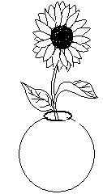

The flower is ___________ the pot.

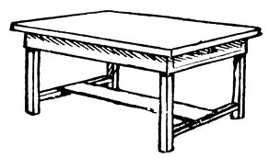

The ball is ___________ the table.

D:\Local Disk F\New folder\KIBUUKA 2023\pictures\kibuuka pic\cup.jpg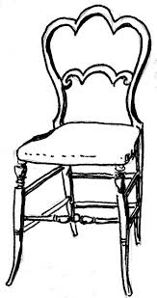

The cup is __________ the chair.

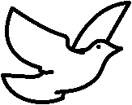

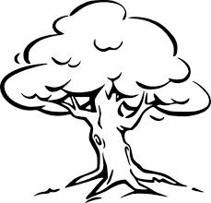

The bird is flying ___________ the tree.

1. D:\Local Disk F\New folder\KIBUUKA 2023\pictures\kibuuka pic\BOTTLE.jpg***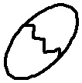*Fill in a or an.**

____egg ____ bottle

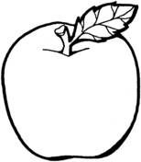******

_____hat _____ apple

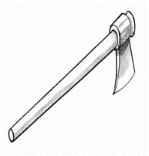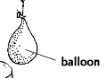

_____ balloon _____axe

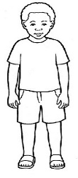**9. Complete the story.**

Here is a __________. He has a ________

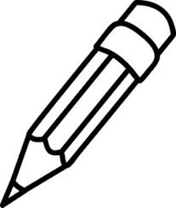D:\Local Disk F\New folder\KIBUUKA 2023\pictures\kibuuka pic\sweet 2.jpg

and a ________ He uses a _________

to write in the ___________.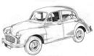

His father has a red _____________.

**END**